**BEER PARISH COUNCIL**

**Financial & General Purposes Committee Meeting**

Wednesday 22nd November, 7 pm, Balcony Room, The Mariners Hall

# AGENDA

You are summoned to attend the **Finance & General Purposes committee meeting** that will be held on **Wednesday 22nd November, 7.00pm at the Mariners’ Hall, Balcony Room**. The meeting will include a maximum of 15 minutes of public participation. Matters raised must be within the remit of the Parish Council. The public will not be allowed to speak at any other time during the meeting unless by prearrangement with the Clerk and Chairman.

1. Apologies

1. Declaration of interests/Granting of dispensation from restrictions on participation and voting on Agenda items.

1. To agree items to be dealt with after the public, including the press, have been excluded.

1. To agree the budget and precept for 2023/24.

1. To consider and adopt the amended job description for the Events and Promotions Coordinator.
2. To note the pay increase as per condition 3.1 in staff contracts of employment: The National Agreement on Pay and Conditions of Service to the Joint Council (NJC) for Local Government Services (the Green Book).

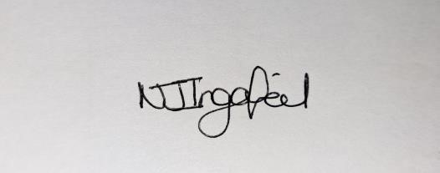

Mrs Nicky Ingarfield

Clerk to Beer Parish Council

Contact: Mariners’ Hall, Fore Street, Beer, Devon EX12 3JB 0781 452 1538 beerparishcouncil@outlook.com [www.beerparishcouncil.org.uk](http://www.beerparishcouncil.org.uk/)